Foundations 3 Answer Template

Out: Thu Feb 10 2022. Due: Fri Feb 18 2022, 6pm

Submit through Gradescope, as a file in PDF format, using this Google Doc answer template. Make a copy of this document by navigating on the toolbar: "File" > "Make a copy"

*Administrative overhead penalty of up to 20% if additional processing work is required to handle your assignment, such as: not following the answer template, uploading an unreadable file, not marking etc.*

## Question 1: Multiple Views

State which type of view coordination is used. More than one type could be used at once.  
Justify your choice(s) very briefly, according to two criteria: whether the views share the same visual encoding; whether they show the same data, or a subset of the data, or disjoint data within each.

* 1.1 Gerrymandering
  + 1.1.1 Small multiples
  + 1.1.2 Same encoding, different data
* 1.2 Antarctic Terrain
  + 1.1.1 Overview/Detail, Multiform
  + 1.1.2 One view shows a subset of elevation data of the other view with different encoding
* 1.3 MizBee
  + 1.1.1 Overview/Detail, Multiform
  + 1.1.2 One view shows a subset of genomic data of the other view with different encoding
* 1.4 Figures in the Sky
  + 1.1.1 Overview/Detail, Same form
  + 1.1.2 The central view shows a bigger version of the selected view with a subset of the same data (more stars) and the same encoding
* 1.5 Explore Adventure
  + 1.1.1 Multiform
  + 1.1.2 Rationale
* 1.6 Olympic Feathers
  + 1.1.1 Small Multiples
  + 1.1.2 Same encoding, different data
* 1.7 Crutch Word
  + 1.1.1 Multiform
  + 1.1.2 One view shows the moving average while the other shows the precise times of when ums occur. It is the same data but with different encoding.
* 1.8 Flight Times
  + 1.1.1 Overview/Detail, Multiform
  + 1.1.2 The other views show a subset of flights of the selected flight date range. The other views show different information about the selected flights in vertical bar charts, a horizontal bar chart and something that’s similar to a scatterplot.

## 

## Question 2: Sketching Geographic Data

### 2.1 Approach 1

#### 2.1.1 Sketch

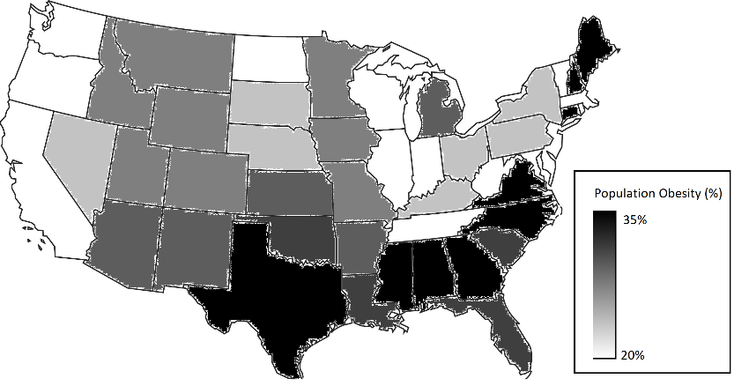

#### 2.1.2 Advantage

Easy to understand

#### 2.1.3 Disadvantage

Hard to differentiate between similar shades

### 2.2 Approach 2

#### 2.2.1 Sketch

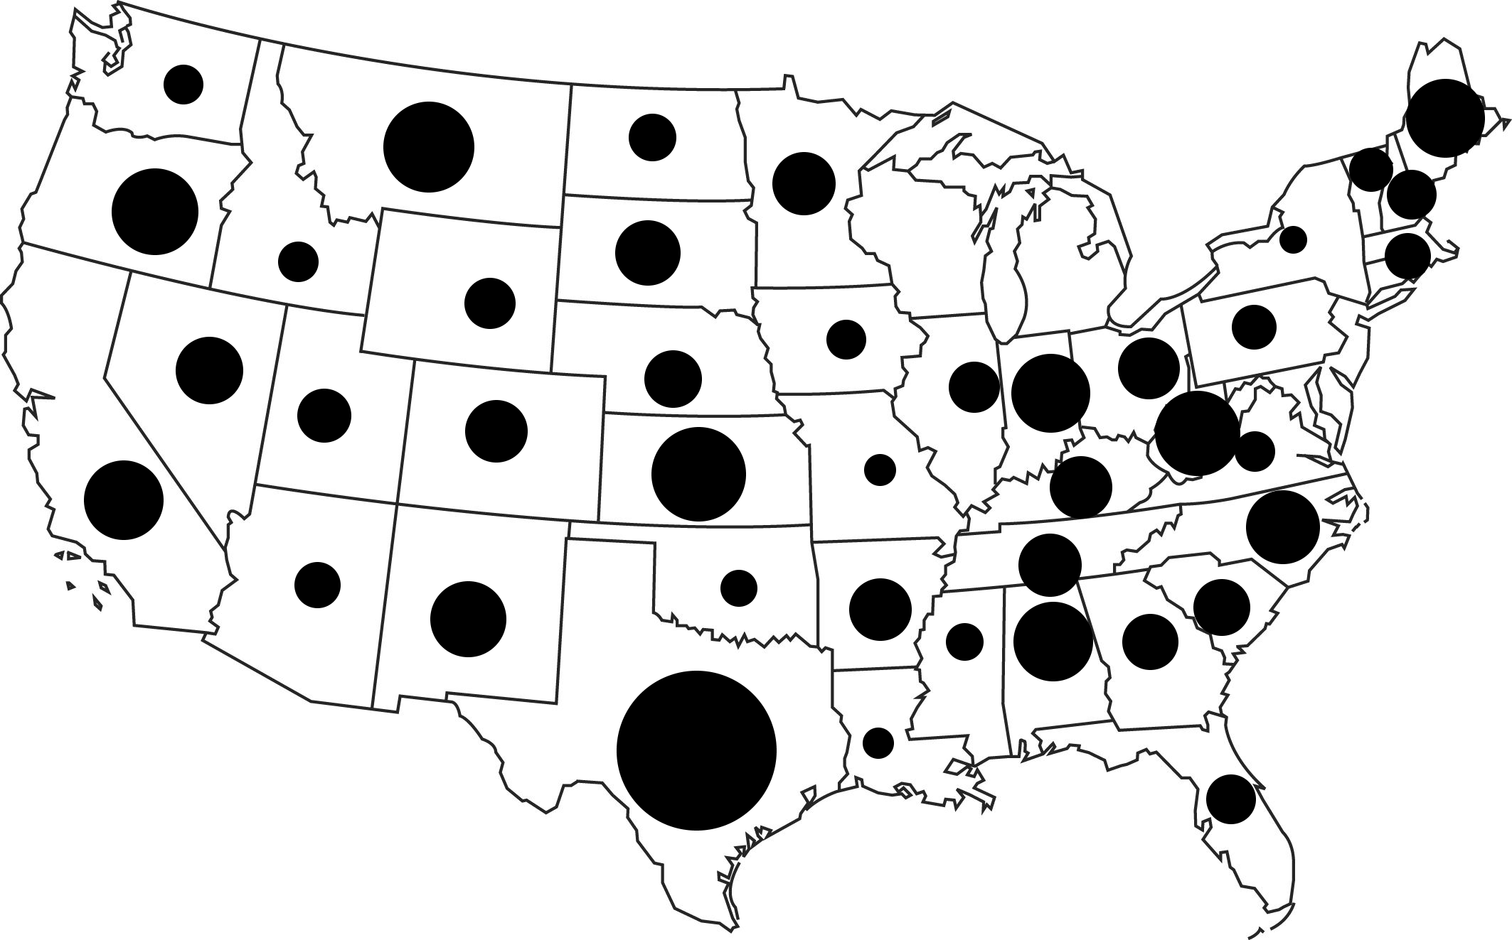

#### 2.2.2 Advantage

Region size does not affect decoding

#### 2.2.3 Disadvantage

Overlapping marks

### 2.3 Approach 3 (Pie charts)

#### 2.3.1 Sketch

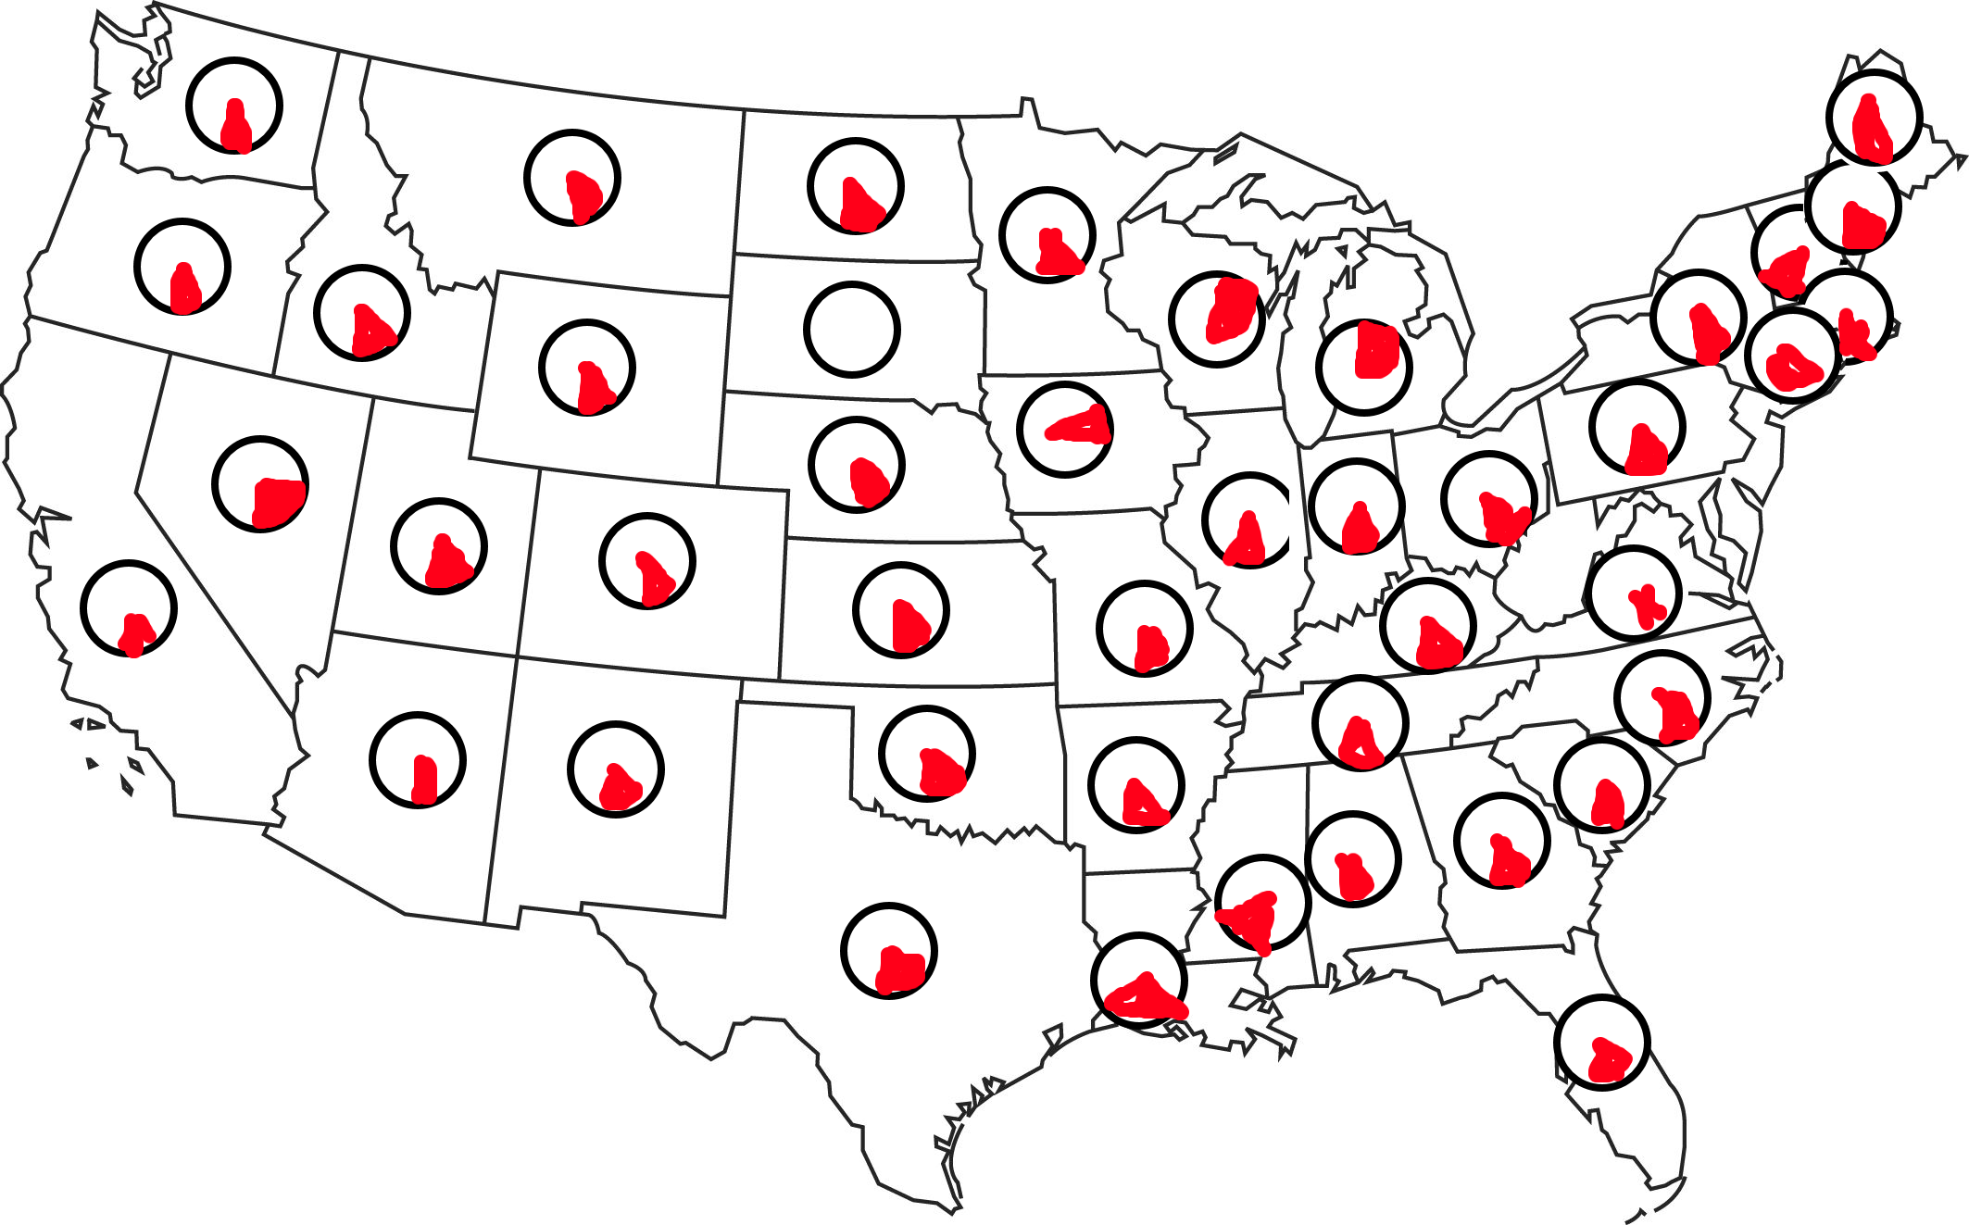

#### 

#### 2.3.2 Advantage

Can more easily see exact value of obesity rate

#### 2.3.3 Disadvantage

Glyphs going over their regional boundary

## Question 3: Twitter Monitoring Application

*In this question you work in a design agency which needs to develop a Twitter Monitoring application for the federal election in a country.*

### 3.1: Design

*Insert your visualization sketch below. If any of the views do not have readable titles, include an annotation label so that you can refer to it below.*

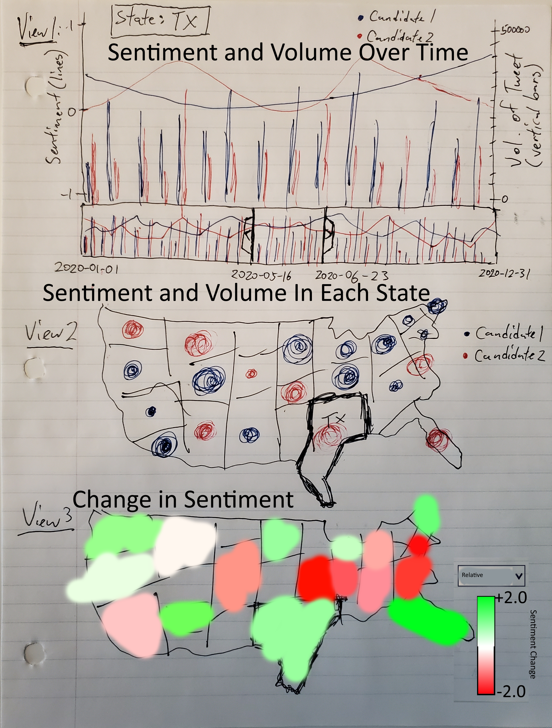

This image shows the 3 views when no candidate is selected. View 2 has a circle in each state with the color representing the candidate with the highest average sentiment in that state and the size of the circle is correlated to the volume of tweets from that state over the time period selected in View 1. View 3 shows the relative change in sentiment between the top and bottom position at the start and the end of the time period. For example, if Candidate 1 lead Candidate 2 by 0.5 points at the start of the time period, but then Candidate 1 trailed Candidate 2 by 0.5 points at the end of the time period, the relative sentiment change would be 1.0. Any relative sentiment change over 0 means that the leader kept their lead and anything less than 0 means that they lost their lead.

## 

This image shows the 3 views when Candidate 1 is selected. View 2 has a circle in each state with its size correlated to the volume of tweets about Candidate 1 from that state over the time period selected in View 1. View 3 shows the change in sentiment for Candidate 1 over the time period selected in View 1. A sentiment change from -1 to +1 represents an absolute sentiment change of +2.0.

### 3.2: Rationale

*Provide a rigorous rationale for your design decisions. For each view in your sketch above, answer the three questions. Add or remove blocks depending on the number of views.*

#### View 1: Sentiment and Volume Over Time

#### Which question(s) does this view support?

Q1: How has the sentiment for candidate X changed over time in each state?

Q2: At time point T, compare the sentiments between both candidates in each state.

Q5: Is the sentiment correlated with the volume of tweets, for either candidate?

#### How does the interaction for this view work, and how is it coordinated/linked with other views?

* There is a drop down menu where the state can be selected. Selecting a state in the other views will also change the selected state in this view. Selecting a state will show the sentiment and volume data for that particular state. There is also an option to select no states, so that it shows the summed sentiment and volume data for all states.
* The candidate can be selected in the legend. Selecting a candidate will select that candidate for all views. Selecting a candidate will only show the sentiment and volume data for that particular candidate. When no candidate is selected, it shows the data for both candidates.
* Mousing over a particular time will show a popup with more detail of the exact sentiment value and volume of that day.

#### How do the marks & channels in this view match up with the data and the question(s)?

* The line mark of the vertical bars, representing volume, is juxtaposed with the point marks of the line, representing sentiment. This can be used to answer Q5, where any correlation between volume and sentiment can be seen with correlated increases or decreases of the line and bars.
* The color channel uses hue to distinguish between the two candidates. This can be used to answer Q2, since the sentiments of the two candidates are plotted on the same chart, so they can be viewed simultaneously.
* When one candidate is selected, the data for the other candidate is hidden, which makes it very easy to see the sentiment for candidate X change over time. To answer Q1, the point marks of the sentiment line show how sentiment changes over time.
* I opted not to include small multiples of this graph, which can allow all states data to be viewed at the same time, since there are 50 states and it would be an overwhelming amount of data and be hard to understand due to the high cognitive load.

#### View 2: Sentiment and Volume in Each State

#### Which question(s) does this view support?

Q4: What is the distribution of the total volume of tweets across the states at time point T? Over all time?

Q6: Are there geographic patterns to the sentiment distributions for the two candidates?

#### How does the interaction for this view work, and how is it coordinated/linked with other views?

* A state can be clicked to draw an outline around it in this view. It will also select that state in the other views.
* A candidate can be selected in the legend. Selecting a candidate will select that candidate for all views. When no candidates are selected, each state will have a circle with the color representing the candidate with the highest average sentiment in that state over the time period selected in View 1. Selecting a candidate will only show the sentiment and volume data for that particular candidate.
* Circles can be moused over to show a popup. The popup includes details such as the volume of tweets and the % volume relative to all tweets in the time frame.

#### How do the marks & channels in this view match up with the data and the question(s)?

* There is a point mark in each state, overlaid on a map of the US, to represent the data in that state.
* The volume of tweets control the area channel of the circles. It is possible to answer Q4 by roughly estimating the area of a circle and comparing it to the other areas. An exact percentage can be viewed by mousing over the circle.
* The color channel uses hue to distinguish between the candidates. When no candidate is selected, it will show the color of the candidate with the highest average sentiment, which makes it possible to see geographic patterns, like a clump of blue circles in a certain area will reveal trends about that region. This can be used to answer Q6. The size of the circle also provides additional information that is relevant to geographic patterns.

#### View 3: Change in Sentiment

#### Which question(s) does this view support?

Q3: In which states has the sentiment changed so that the most positively discussed candidate flips from one to the other candidate, between time points T1 and T2?

Q6: Are there geographic patterns to the sentiment distributions for the two candidates?

#### How does the interaction for this view work, and how is it coordinated/linked with other views?

* A state can be clicked to draw an outline around it in this view. It will also select that state in the other views.
* A candidate can be selected in the legend. Selecting a candidate will select that candidate for all views. When no candidates are selected, each state will be colored to represent the relative change in sentiment between the top and bottom position at the start and the end of the time period selected in View 1. Selecting a candidate will only the change in sentiment for that particular candidate.
* Mousing over a state will show a popup with the initial and final sentiments of the candidate(s) over that time period.

#### How do the marks & channels in this view match up with the data and the question(s)?

* The color channel uses hue to differentiate between positive and negative sentiment change. It also uses saturation to show the relative amount of change from 0 sentiment change. This can be used to answer Q3, since a flip in sentiment would be shown as red on the map and a deeper saturation would correspond to a the high magnitude of change.
* The interlocking areas mark contains the data for each state. This can be used to answer Q6, since geographic patterns regarding changes in sentiment are apparent when they are grouped together on the map.

## Question 4: Color Channels

*Write which color channels are used for each row in the table below*

|  |  |
| --- | --- |
| **4.1** | hue |
| **4.2** | luminance |
| **4.3** | hue, luminance |
| **4.4** | hue, saturation |

## Question 5 Design Color Palettes

*For each of the four subquestion, include a screenshot of your result (showing both swatches legend and the map) and a brief explanation. (Explanation should be typed, not handwritten.)*

### Question 5.1: Consumer Spending

#### 5.1.1 Screenshot

#### 

#### 5.1.2 Explanation

#### I chose to use a diverging color scale to show the data. White would represent people who spend what they earn, black would represent people who live way below their means and red would represent people who live above their means. I think it is divergent because there are two scales. The first ranges from 0% to 100% of their income for people who live below their means. The second ranges from 100% to a potentially unlimited value for people who live way above their means.

### Question 5.2: Toxic waste

#### 5.2.1 Screenshot

#### 

### 5.2.2 Explanation

### I think this is also sequential, with the values ranging from white, meaning no accumulated toxic waste, to dark red, meaning high accumulation of toxic waste.

### Question 5.3: Distinguish every color

#### 5.3.1 Screenshot

#### 

#### 5.3.2 Explanation

#### There are 10 unique colors for this categorical attribute. I used hue in this palette since humans are much better at distinguishing hue than luminance or saturation for a large number of items.

### Question 5.4: Favorite ice cream

#### 5.4.1 Screenshot

#### 

#### 5.4.2 Explanation

Since there are 15 flavors, I chose a categorical attribute with 15 values. I found it hard to get more distinguishable hues beyond the ones already present, so I added black and white, which are quite distinguishable from the hues.